WEEK 1, HW1: DESCRIPTIVE STATISTICS (PLEASE READ ALL THIS CAREFULLY AS IT WILL HELP YOU THROUGH THE WHOLE COURSE INCLUDING THE QUIZZES AND FINAL EXAM)
We start with DESCRIPTIVE STATISTICS where we simply want to “see” what our data set looks like. Later in the course we move on to INFERENTAIL STATISTICS where we try to learn what our sample data can tell us about the actual, entire population from which our sample was taken.

INTRODUCTION: There are a 1001 expressions that relate to statistics in our lives. My favorites are:
- ‘‘Life is a crap shoot”,
- “Pay your money, and take your chances”, and
- “What could possibly go wrong?” (This is the “mantra” of the Darwin Awards).

Of course there is DENIAL that shows how we ignore data and the statistical analysis of it:
- “My mind is made up, don’t confuse me with the facts !!”,
- “ I really want that car; I don’t care about its safety rating or gas mileage!”,
- “I love fried chicken and pork BBQ; I don’t care about the cholesterol and salt !”,
- “I don’t need a flu shot !”,
- “So I’m overweight, smoke, and drink Coke ^{tm} who cares ?!”
- “I only buy ‘organic’ produce, milk and eggs; it’s worth the much higher cost.”
- ‘’I can handle four courses including Stat 200 even if I’m weak in math, am moving and have a baby on the way.’’
What statistical denials have or are YOU making?

WHY?: Research suggests that our brain’s pre-frontal cortex does not mature or “kick-in” until our early twenties. This cortex is where experiences are tied together and we start to see the possible consequences of our actions. Up to then, we are “immortal”, as in the “Born to Be Free” song. Of course some life events (violence) speed up this process, which you can imagine, and not always in a good way. Then again, some of us never “mature.” Moving on . . .
Most of our life decisions are (or should be) based on statistics: what is the safest car to buy, what picks should I make for my fantasy team, what foods are heathiest, what medicine can best relieve my headache, can I afford this house, what degree offers the highest job/salary potential, which lottery ticket should I buy, which political candidate will best help me (preferably, which will be best for our country), etc.
We base many of these decisions on the ads we’ve seen or read. Those ads cite studies conducted on their products or services. Those studies are statistically based (though NOT necessarily sound statistics). If you watch any TV show you have seen countless ads for drugs that spend more time listing possible hazards than likely benefits. Wonder why? This is a CYA deal. In the testing or actual use of their product, some persons have developed those conditions. We hope they are rare occurrences, but we aren’t given that information (pay your money, take your chances).
In making all these corporate and personal decisions they and we need DATA. Keep in mind that the goal is to predict what an entire POPULATION (e.g., age group) will do based on SAMPLES taken from that population.
PARAMETERS VERSES STATISTICS.
THE MEAN AGE OF A POPULATION IS 45 YEARS. THIS VALUE IS A PARAMETER BECAUSE IT REFERS TO THE ENTIRE POPULATION.
THE MEAN AGE OF A SAMPLE FROM A POPULATION OF 100,000 IS 45 YEARS. THIS MEAN IS A STATISTIC SINCE IT REFERS TO A SAMPLE (NO MATTER HOW LARGE).
STATISTICAL ANALYSIS ALLOWS US TO MAKE PREDICTIONS ABOUT A POPULATION BASED ON SAMPLES FROM THAT POPULATION. It gives us the odds (the probability) of success (or failure).
Now, let’s assume you ARE a mature “critical thinker” who seeks out hard data and valid statistical analyses (good luck with that). It’s out there in “peer-reviewed” studies and sound science research, if you look. BUT, it’s much easier to find the more readily available, typically very biased data – the “alternative facts.” BUT, let’s be clear – there are NO alternative facts. Facts are facts. There may be different interpretations of why something is a fact, but not that there is a different fact.
So, how do we handle these different interpretations? We BALANCE THIS BIAS, meaning look at the extreme views and their supporting data and then form OUR own opinion from these extremes, this can work. This is CRITICAL THINKING and is what education is all about. Unfortunately, as this topic stated up front, far too many of us simply pick the data sources that match, for whatever reason, our personal biases, and that polarization certainly stops any compromise, meaning progress, that would ultimately benefit us all. Moving on . . (again):
Let’s talk “DATA”. What is it and how do we collect it, but most importantly what makes it good, meaning valid. There are two types of data: qualitative and quantitative.
- QUALITATIVE: Color of cars, taste of beer (hoppy, fruity, molasses), rankings like “unsatisfied, satisfied, very satisfied”, numbers like 1-4, $$$, , etc.)
- QUANTITATIVE: Heights, weights, income, home prices, IQ, test scores; almost anything that can be measured mathematically (except numerical rankings). There are two types of quantitative data: discrete and continuous:
  - DISCRETE: These are WHOLE numbers like number of children, where an average, if not a whole number might sound ridiculous (e.g., average U.S. family has 2.6 children).
  - CONTINUOUS: Numbers where fractions are realistic like heights, weights, age. Money can go either way, but let’s go with continuous. Rounding off can create some error.
There are FOUR SCALES or LEVELS of MEASUREMENT used for these above data types and this is important to remember (Final Exam likely question-Illowsky p-26).
- NOMINAL (scale or level): Qualitative data are measured on this scale. The unique characteristic is that no statistical calculation works (would be invalid or nonsense) on NOMINAL data. Even putting the choices like car colors in a particular order makes no real sense: red, yellow, white, blue. . . So what now?

- ORDINAL (scale or level): Qualitative data can also be measured on this scale. Here we have our RANKINGS using choices like poor/fair/good or $$$ or even numbers 1-4 . Data measured on this scale CAN be put into a meaningful order in that $$$$ is logically higher than $$. HOWEVER, ORDINAL scale data as with Nominal scale data can NOT be analyzed statistically. How much better is a restaurant with 3 “smiley faces” than one with 2 smiley faces? We can’t calculate this and more importantly we don’t know what each ranking was based on. People may like the style of food, its presentation, its quantity, or they may not like dirty silverware, or unclean restrooms. Who knows ?? You may even be asked to rank each of these qualitative areas, but they are still QUALITATIVE, hence this data cannot be analyzed statistically. Also, be careful with numerical rankings like “1 – 5”. These are no more appropriate for statistical analysis than smiley faces.
- INTERVAL (scale or level): We have meaningful numbers. Some Quantitative data are measured on this scale, BUT this scale has NO ZERO POINT. Temperatures are a good example. Differences in data DO make sense, BUT comparisons do not. You can calculate average summer/winter temperatures for an area, let’s say 80 ºF / 20 ºF BUT we can NOT say that it is 4 times hotter in summer than winter. Why? Because the 0 ºF or 0 ºC are NOT absolute zero. Temperature measured in the KELVIN scale DO go down to absolute zero (when all molecular motion stops). On this scale we CAN say the 100 K is twice as hot as 50 K where “hot” refers to the amount of molecular motion. This motion can be “seen” when you boil water and the molecules of water actually have enough energy to “jump out” of the liquid phase and become steam (gas phase). (The other state of matter is solid like ice). You can even “freeze” (solidify) the gas CO₂ as dry ice. Confused?
- RATIO (scale or level): Now we’re talking !! We have QUANTITATIVE data and a meaningful zero and we can do ALL the statistical calculations that might apply to this data set. An example would be class grades based on points earned out of 100. This works for most courses with multiple choice tests, but what about essay questions. Can you statistically compare the grades in a course in which grades are based totally on multiple-choice exams to one (in the same subject) in which the grade is based totally on essay question exams? NO ! So be careful that you are ALWAYS comparing apples to apples. This is where knowing what the data are based on is the FIRST critical consideration in evaluating any statistical analysis.
Data collection or “SAMPLING” is the next topic. What are we sampling? These are samples of a specific characteristic of an entire POPULATION, and it is RARELY possible to sample an entire population. But, if we did and calculated the mean of all those data, that mean would be considered a PARAMETER of the population. HOWEVER, the mean of a sample is referred to as a STATISTIC. REMEMBER THIS (Final Exam likely).
There are FIVE data collection or sampling protocols we will cover, the INTENT of all is to get a REPRESENTATIVE SAMPLE of the population. (methods –Illowsky p-18):
- SIMPLE RANDOM sampling is the first. “Random” means that EVERY piece of data has an EQUAL chance (probability) of being collected. You have twenty grandchildren that you like equally well but you can only afford to send $10 holiday presents to five (the rest get $5 each). PUT THEIR NAMES IN A HAT AND DRAW OUT FIVE.
- STRATIFIED: Divide the population in to logical groups (or strata which means layers - a little confusing). You want to determine the average age of students in each of the ten UMUC departments (let’s assume there are only ten). Then, take a simple random sample of students from each Dept.
- CLUSTER: This sampling method starts like Stratified in that all groups in a population are identified. BUT, then we use simple random sampling to decide on only a portion (cluster) of those groups. Next, we use simple random sampling to collect our data from each of groups in that cluster. For example: all nursing homes (let’s say 35) in a State were given a new medication to try for reducing memory loss. The, 10 of these homes were selected at random (names in a hat). ALL residents in those 10 homes were then tested.
- SYSTEMATIC: A little tricky. Remember that we want EVERY person or item in the population to have an equal chance of being selected. So, this seems to require that we know the size of our population. We also need to decide how many samples we can afford to take. Divide the population size by the sample size and save that number. We then pick our starting point from a random numbers table or generator and proceed to collect the desired data (information) from every “saved number” person or item. Let’s say 1000 TV’s are produced a day (assembly line) and we want to sample 10% (100) for QA. So, 1000/100 = 10. We pick a random number (it could be 3), so we start with the third TV on the line and then pick every 10th TV after that until we get our 100. This is the ‘’system’’ - We don’t randomly pick TV’s coming down the line.
- CONVENIENCE: It is what it is. Poll the classmates, poll the neighbors, count the cars at a nearby intersection. Some of the results from this sampling methodology will produce valid statistical results, but MANY won’t. This could be deliberate BIAS and assumes that readers will NOT question or look into how the data were collected.
One last issue with DATA SAMPLING is whether sampling is done WITH REPLACEMENT OR NOT. Taking a large number of samples from a phone book might require going through the book multiple times. With simple random sampling, you would possibly hit the same name twice (or even more). Does this matter? MAYBE. If you ignore a repeat (non-replacement), you actually improve the odds (probability) for the other names or items.
FOR EXAMPLE, If 5 winners are pulled from 20 names in a hat and yours is one name out of the 20 in the hat, your odds of winning on the first pick are 1/20 (=0.05 or 5%). It you did NOT win on the first pick and the winner’s name is NOT put back in the hat, your odds improve to 1/19 (=0.053 = 5.3%) and continue to get better with each losing selection. BUT, if the winners’ names are put back in the hat, your odds stay at 5% with each pull as do the odds for the prior winners to win again. For samples from a LARGE population replacement is not that critical.
HERE ARE THIS WEEK’S HOMEWORK PROBLEMS (DUE TO ASSIGNMENT FOLDER BY 11:59 PM EST SUNDAY)
#1. You are going out to eat. There are three shopping malls nearby and each has up to five restaurants (these restaurants are all different styles: e.g., Italian, Chinese, French). Here are their customer SATISFACTION ratings on a scale of up to five +’s (highest satisfaction). WHAT DOES “SATISFACTION” MEAN?
Mall 1 Mall 2 Mall 3
(a) ++++ (a) +++ (a) +++++
(b) ++++ (b) ++ (b) ++++
(c) ++++ (c) +++ (c) +++
(d) ++ (d) +
(e) +++

#2. (a) What type of data and scale are involved here?
(b) Which Mall Restaurant did you pick? WHY?
(c) What issues could you encounter with your pick once you got there?

At the beginning we dealt with what data are and how to collect valid random data. We also talked about how data “samples” are intended to give us an idea of an entire population. Of course sample size affects everything.
We now continue with DESCRIPTIVE STATISTICS concepts, such as DISPLAYING our data in the hopes of seeing some pattern as distinctly as possible. So, who cares if there is a pattern? Well, if we see a bell curve shape we likely have a NORMAL distribution and all our statistical analyses will work (could give us valid results).

#3. NOW, LET’S DEAL WITH THE MORE COMMON AND USEFUL QUANTITATIVE DATA (DISCRETE LIKE 1, 2,3, 4 AND CONTINUOUS LIKE 3.2, 5.6, 7.9). ONE OF THE KEY DESCRIPTIVE TOOLS TO LOOK FOR PATTERNS IN DATA, HENCE HELP FORMULATE CONCLUSIONS, IS GRAPHING.
REVIEW OF GRAPHING: FOR SIMPLICITY HERE ARE 6 DATA POINTS: 5, 9, 4, 16, 13, 18
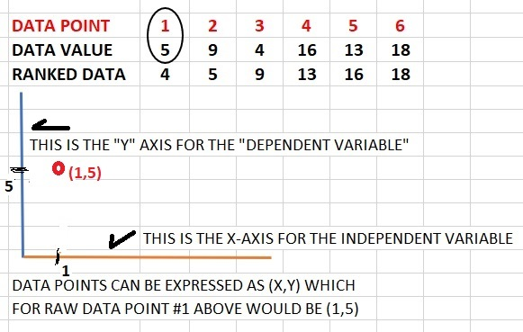 | 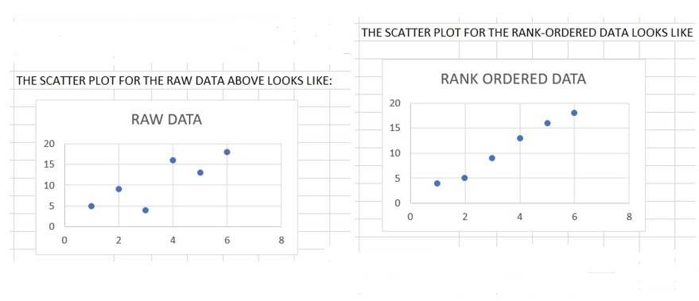

AS AN EXAMPLE, LET’S SAY YOU ARE PLANNING ON BUYNG A NEW VEHICLE. THERE ARE THREE MAKES WITH SIMILAR MODELS (LIKE AN SUV) THAT YOU ARE CONSIDERING. ONE CRITICAL CONCERN IS THE MILEAGE BEFORE A MAJOR REPAIR IS REQUIRED. YOU INTERVIEW REPAIR SHOPS AND COLLECT DATA ON THE 1000’S OF MILES BEFORE A MAJOR REPAIR > $1000 FOR THREE MAKES: “A”, “B” AND “C”
"A" RAW DATA: 15 24 23 19 80 24 22 29 70 22 31 23 22 72 30 26 25 28 25 24 27 75 32 34 26 27 24 69 26 22
"B" RAW DATA: 35 38 39 41 19 14 34 31 40 35 14 32 39 12 34 42 38 33 37 42 18 33 42 35 34 37 34 36 41 36
"C" RAW DATA: 34 33 31 32 35 32 31 33 33 33 34 32 35 31 21 59 34 33 32 31 33 35 32 31 30 33 34 35 32 34
BUT, always remember that statistics proves NOTHING by itself. The calculated numbers simply give us support for our hypothesis (our ideas). Remember too that as with stock prices, past data do NOT predict future performance. Of course all statistics mean NOTHING IF the data are not true random samples that reflect the entire population of concern.

NOW, (a) DRAW A SEPARATE SCATTER PLOT AND RANK-ORDERED PLOT FOR EACH MAKE OF VEHICLE
(b) EXPLAIN IF ANY OF THESE SIX PLOTS HELP YOU MAKE A DECISION ON WHICH MAKE TO BUY, AND WHY.

NEXT: OPEN THE EXCEL TABLE PROVIDED WITH THIS HOMEWORK AND ANSWER THE FOLLOWING QUESTIONS
#4. Draw a vertical (or horizontal) BAR CHART that compares each month’s total income AND total expenses (TWO BARS PER MONTH FOR THE 12 MONTHS )
#5. Draw a PIE CHART showing the total ANNUAL cost split among these three EXPENSE categories: gas, food, electricity (a hand drawing is fine). EXPLAIN HOW EXCEL OR YOU DETERMINED THE ANGLES OF THE 3 WEDGES IN THE PIE CHART (DUST OFF GEOMETRY AND TRIG)
#6. Draw a STEM & LEAF diagram of the MONTHLY INCOME numbers. Explain how you would handle this if the expenses had more significant digits (e.g., $3189 instead of $3200, etc.). This is a possible shortcoming of displaying data in a stem & leaf diagram)
#7. Draw a DOT PLOT for any one data column (Few seem to get this one right). Try putting the $-amounts along the bottom axis and a dot ABOVE that number for each time its value occurs.
#8. SUMMARIZE (in your own words AFTER researching a little) what each of the data displays (i.e., pie chart, bar graph, stem & leaf, and dot plot) above is BEST suited for and what, if any, are its LIMITATIONS. Which display do you feel gave you the best “picture” of the shape of the data distribution and/or the most information about it? CITE THE SOURCE(S) OF YOUR OUTSIDE, RESEARCHED ADVICE.

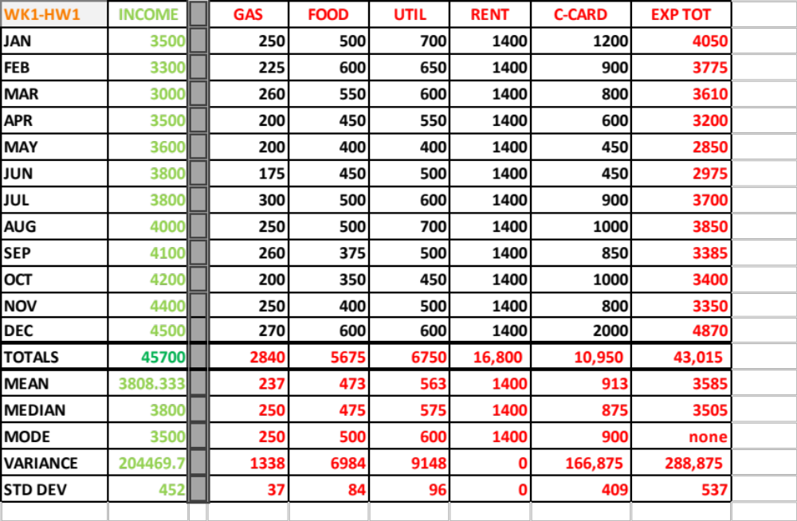

Same as picture, easy to copy and paste
WK1-HW1 | INCOME |  | GAS | FOOD | UTIL | RENT | C-CARD | EXP TOT
JAN | 3500 |  | 250 | 500 | 700 | 1400 | 1200 | 4050
FEB | 3300 |  | 225 | 600 | 650 | 1400 | 900 | 3775
MAR | 3000 |  | 260 | 550 | 600 | 1400 | 800 | 3610
APR | 3500 |  | 200 | 450 | 550 | 1400 | 600 | 3200
MAY | 3600 |  | 200 | 400 | 400 | 1400 | 450 | 2850
JUN | 3800 |  | 175 | 450 | 500 | 1400 | 450 | 2975
JUL | 3800 |  | 300 | 500 | 600 | 1400 | 900 | 3700
AUG | 4000 |  | 250 | 500 | 700 | 1400 | 1000 | 3850
SEP | 4100 |  | 260 | 375 | 500 | 1400 | 850 | 3385
OCT | 4200 |  | 200 | 350 | 450 | 1400 | 1000 | 3400
NOV | 4400 |  | 250 | 400 | 500 | 1400 | 800 | 3350
DEC | 4500 |  | 270 | 600 | 600 | 1400 | 2000 | 4870
TOTALS | 45700 |  | 2840 | 5675 | 6750 | 16,800 | 10,950 | 43,015
MEAN | 3808.333 |  | 237 | 473 | 563 | 1400 | 913 | 3585
MEDIAN | 3800 |  | 250 | 475 | 575 | 1400 | 875 | 3505
MODE | 3500 |  | 250 | 500 | 600 | 1400 | 900 | none
VARIANCE | 204469.7 |  | 1338 | 6984 | 9148 | 0 | 166,875 | 288,875
STD DEV | 452 |  | 37 | 84 | 96 | 0 | 409 | 537

